B.H. COLLEGE
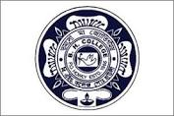
HOWLY:: BARPETA::ASSAM
DEPARTMENT: Education | DATE: 22-06-2022
No. of Students/Participants | 61
Title of the Programme
Motivational speech cum Farewell
Name of the Resource Person
Dr. Birendra nath Chakraborty
Principal
Barnagar College, Barpeta
Objective of the Programme

- To provide motivation regarding career and life
Description of the Programme
The Motivational programme was held on 22/06/2022 on Room No- 105 at B H College premise. The speaker delivered speech on human values and futuristic goals for career and life. The Students and the Teachers of the Department took part actively in the session.

